

**Application of the Surface Conduction Transducer to the Design of a Class-D amplifier**

By

Arturas Kazenas

This report is submitted in partial fulfilment of the requirements of the Degree in Electronic and Communications Engineering (DT008) of the Dublin Institute of Technology

10th April, 2018

Supervisor: Dr Patrick (Pádraig) McEvoy

**DECLARATION**

I, the undersigned, declare that this report is entirely my own written work, except where otherwise accredited, and that it has not been submitted for a degree or other award to any other university or institution.

Signed: _____________________________

Date: ________________

**Acknowledgements**

This project would not been possible without the advice and guidance of a group of exceptional staff members in the school of Electrical and Electronic Engineering at Dublin Institute of Technology.

I would like to show my gratitude to Mr. Martin Sorohon (Dublin Institute of Technology, Kevin Street) for his help in finding, downloading and implementing PSpice libraries and symbols that were required for modelling and simulating circuit behaviour.

I would also like to thank the Mr. Ronald Göbl and Mr. Tom Fallon (Dublin Institute of Technology, Kevin Street) for providing advice, equipment and components used during assembly and testing of the prototypes.

I would like to thank Mr. Domnick Nardone for sharing his valuable insight in some circuit designs which were considered during the design stage of the project.

Lastly, I would like to thank the project supervisor Dr Pádraig McEvoy for his guidance, advice and supervision of the project from initial to final stages of the project

**Abstract**

The initial aim of the project was to build, test and analyse the operation of a Class-D amplifier incorporating a surface conducting transducer that will convert electrical signals from any electronic device with a 3.5mm jack port into vibrations which when in contact with a surface or cavity will conduct and produce an audible sound. An input audio signal is required for amplification to produce audible sound. In this case, a class-D amplifier was chosen due to its high-power efficiency and low power dissipation.

Not all the objectives were met due to numerous setbacks and time constraints. The final version of the project includes a modulator circuit which was designed to perform pulse width modulation of an incoming audio signal. Research, designs and simulation results were made for the rest of the amplifier circuit but did not make it to the assembly stage of the overall project.

Contents

1 Introduction 2

1.1 Project description 2

1.1.1 Aim of report 2

1.1.2 Project background 2

1.1.3 Structure of report 2

2 Project research 2

2.1 Class-D amplifier 2

2.2 Modulation techniques 2

2.2.1 Design requirements 2

2.2.2 Pulse width modulation 2

2.2.3 Pulse density modulation 2

2.3 Audio amplifiers 2

2.3.1 Design requirements 2

2.3.2 Half-bridge topology 2

2.3.3 Full-bridge topology 2

2.4 Signal processing 2

2.4.1 Design requirements 2

2.4.2 Butterworth filter 2

2.5 Bone conduction transducer 2

2.5.1 Component description 2

2.5.2 Applications 2

2.5.3 Possible dangers and side effects 2

2.6 Initial design 2

3 Technical description and construction details 2

3.1 Pulse width modulator 2

3.1.1 Component list 2

3.1.2 LM555 timer 2

3.1.3 Technical design 2

3.1.4 LM741 2

3.1.5 Assembly 2

3.2 Class-D amplifier 2

3.2.1 Component list 2

3.2.2 Technical design 2

4 Test procedures and results 2

4.1 LM555: Oscillation frequency testing 2

4.1.1 Aim of test 2

4.1.2 Equipment used 2

4.1.3 Method 2

4.1.4 Results 2

4.1.5 Observations 2

4.1.6 Comments 2

4.2 Modulation test 1 2

4.2.1 Aim of test 2

4.2.2 Equipment used 2

4.2.3 Method 2

4.2.4 Results 2

4.2.5 Observations 2

4.3 Modulation test 2 2

4.3.1 Aim of test 2

4.3.2 Method 2

4.3.3 Results 2

4.3.4 Observations 2

5 Conclusion 2

6 Recommendations 2

7 References 2

8 Appendices 2

8.1 Block diagram 2

8.2 Schematic diagrams 2

8.3 LM555 pin layout 2

8.4 TL082 pin layout 2

8.5 LM741 pin layout 2

8.6 TL084 pin layout 2

8.7 Components list 2

8.8 Photos of results 2

8.9 Graphed results 2

8.10 Photos of stripboard circuit 2

8.11 Project schedule 2

Figure 1: (Class-D amplifier, 2018) [2] 2

Figure 2: (The output-signal pulse widths vary proportionally with the input-signal magnitude. (2007) [3] 2

Figure 3: (Arduino, 2018) [5] 2

Figure 4: Half-bridge rectifier circuit 2

Figure 5: Full bridge rectifier circuit 2

Figure 6: First order low pass Butterworth filter 2

Figure 7: (Parts Express, 2018) [7] 2

Figure 8: Initial design of project base on initial research 2

Figure 9: LM555 timer configured in the a-stable mode 2

Figure 10: PSpice schematic of the LM555 in the a-stable mode 2

Figure 11: Voltage waveforms displayed for the output on pin 3 and the capacitor voltage 2

Figure 12: LM741 voltage divider with an audio signal and reference voltage compared 2

Figure 13: PSpice simulation of pulse width modulation 2

Figure 14: Oscillator assembled on a breadboard 2

Figure 15: Pulse width modulation circuit assembled and soldered on to stripboard 2

Figure 16: LM741 vs TL082 modulation 2

Figure 17: Switching circuit 2

Figure 18: Two MOSFET gate terminals being loaded by the gate driver 2

Figure 19: LM555 oscillating voltage signal compared with a function generated sinusoidal signal 2

Figure 20: TL082 PWM output signal 2

Figure 21: TL084 comparator voltage inputs 2

Figure 22: Output of the voltage TL084 comparator 2

Figure 23: Initial design of the class-D amplifier circuit 2

Figure 24: Spice schematic of the TL082 voltage comparator 2

Figure 25: PSpice schematic diagram of the LM555 timer in the a-stable mode 2

Figure 26: PSpice schematic of the non-linear amplifier circuit with a square wave input 2

Figure 27: (Texas Instruments, 2015) [9] 2

Figure 28: (Texas Instruments, 2015) [10] 2

Figure 29: (Texas Instruments, 2015) [11] 2

Figure 30: LM555 oscillating waveform with no external capacitor 2

Figure 31: LM555 oscillating waveforms with an external capacitor 2

Figure 32: Capacitor values used during frequency testing of the LM555 2

Figure 33: Oscillating frequency difference between expected and measured values during testing 2

Figure 34: Photo of the pulse width modulator circuit (Top view) 2

Figure 35: Photo of the pulse width modulator circuit (left-side view) 2

Figure 36: Photo of the pulse width modulator circuit (right-side view) 2

**Table 1: List of components used in pulse width modulation** 2

**Table 2: List of components used in switching circuit** 2

**Table 3: Test result from the LM555** 2

# Introduction

## Project description

### Aim of report

This report includes the research, design and assembly of the overall class-D amplifier project.

The initial aim of this project was to design and build a device that would amplify incoming audio signals, amplify the amplitude and output the signal in the form vibrations using a transducer. Conducting the vibrations along materials of different shapes and physical properties when in contact with the transducer would allow the vibrations to propagate out into the air as sounds of different frequencies creating a very basic speaker.

### Project background

The circuit takes an audio signal from an electronic device such as a smartphone or laptop and modulates the signal into a high-frequency square wave that is fed to a MOSFET driver to drive a pair of power MOSFET half bridge circuit. The result is an amplified high-frequency square wave. Frequencies above 20 kHz are removed before reaching the transducer by a low pass Butterworth filter removing the higher frequencies which the human ear cannot detect. The current of the resulting amplified signal is being fed to the surface conduction transducer. The transducer itself consists of a metal rod with a voice coil wrapped around it. The pulsating current from the amplifier will travel around the voice coil creating a magnetic field which will cause the metal to expand and contract inside. When pressing the transducer against a surface or cavity, the vibrations will conduct along the object and propagate out into the air in the form of audible sound making it act as a speaker.

### Structure of report

This report includes research conducted in the preliminary version of this report regarding the class-D amplifier. The report includes a detailed description of experiments performed, their results followed by a discussion of those results concerning the performance and efficiency of the circuit made in the previous progress report including the final report.

# Project research

### Class-D amplifier

Class-D amplifiers or switching amplifiers, are popular components in mixed-signal IC design and widely adopted for smartphones and tablets with rich multimedia, thanks to the high-efficiency and high-output power capability [1].

The class-D amplifier is a non-linear amplifier. Signals are amplified using a frequency switching circuit made up of two complementary MOSFET transistors. Each transistor is complementary to each other meaning one transistor is turned on while the other is turned off. This high-speed switching between on and off states of the transistors is what makes the class-D amplifier much more efficient than linear amplifiers. However, the high frequencies introduce noise into the system distorting the signal.

Non-linear amplifiers dissipate less power and therefore heat. This makes them more suitable for smaller and more portable circuit designs.

The design of a class-D amplifier varies based on its application. The most basic design for an amplifier includes a modulator circuit, a switching circuit and a low pass filter.

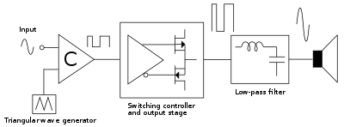

Figure : (Class-D amplifier, 2018) [2]

### Modulation techniques

### Design requirements

The modulation stage is an essential part of the amplifier, because the loss of information in the process of modulation significantly disturbs the quality of the audio signal at the output.

The following aspects of the circuit are considered:

* + An audio signal ranges between frequencies 20 Hz - 20 kHz. This is not high enough for an efficient switching circuit.
  + The input signal should be modulated to at least ten times the maximum frequency of the audio signal (typically 200 kHz) to make sure to avoid harmonic distortion. This removes the need for an additional filtering circuit.
  + A high-frequency input is required to perform high-speed switching of the transistors to improve efficiency.
  + There are two modulation techniques used: pulse width modulation (PWM) or pulse density modulation (PDM).

### Pulse width modulation

The pulse width modulation technique uses a voltage comparator to compare the voltages of an incoming audio signal with a triangle or sawtooth reference waveform generated by an oscillator at a much higher frequency.

The output of the comparator is pulled high or low whenever the input signal voltage crosses the voltage of the triangle/sawtooth waveform. The amplitude of the input signal is translated into the pulse widths of the modulated signal.

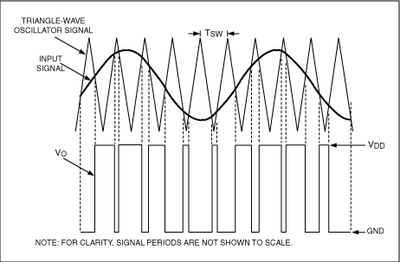

Figure : (The output-signal pulse widths vary proportionally with the input-signal magnitude. (2007) [3]

### Pulse density modulation

In pulse density modulation, the number of pulses in a time window is directly proportional to the average value of the input audio signal. Due to the high switching frequency of this technique more power is dissipated than in the PWM technique. However, PDM provides better linearity minimising distortion.

PDM is a less popular modulation scheme for Class-D amplifiers. It has more randomised switching for better electromagnetic interference (EMI,) and requires a higher average switching frequency to achieve comparable signal to noise (SNR) performance [4].

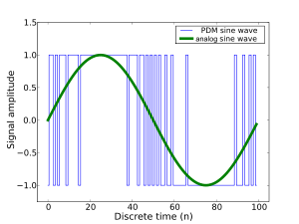

Figure : (Arduino, 2018) [5]

## Audio amplifiers

### Design requirements

Switching circuits are designed to perform high-frequency switching between a pair of transistors and amplify the incoming signal. MOSFET’s are preferred in high-frequency switching applications due to their superior frequency response and very low heat dissipation qualities.

The following aspects of the circuit are considered:

* Transistors must be switching as quickly as possible between the on and off states to increases efficiency.
* Transistors must not be on at the same time as this will cause the circuit to short and cause damage.
* The time where both transistors are switched off during the operation of the circuit must be minimised as much as possible as this creates distortion in the signal. This time is referred to as “dead time”.

A gate driver IC is used to take the low power output of the modulator and outputs higher currents to the gates of each MOSFET transistor. This ensures that the transistors are being turned on and off thoroughly in the least amount of time to reduce heat dissipation and distortion by minimising dead time.

There are normally two topologies that are considered when designing a switching circuit, the half-bridge or the full-bridge topology.

### Half-bridge topology

A half bridge consists of one pair of MOSFETs to perform high-frequency switching. The switches are turned on and off complementary to each other with a short dead time in between. A short dead time is required to avoid the supply current from conducting across both transistors. This can cause significant heat dissipation and can even damage the MOSFETs. The half bridge requires a dual power supply for switching an n channel MOSFET and a P channel MOSFET.

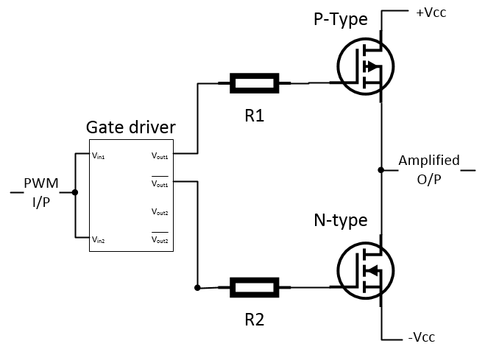

Figure : Half-bridge rectifier circuit

### Full-bridge topology

A full bridge uses two half-bridge stages to drive the load differentially. The full-bridge configuration operates by alternating the conduction path through the load. This allows bi-directional current to flow through the load without the need of a negative supply or a DC-blocking capacitor. [5] However this design requires double the amount components making it more complicated, causing it to dissipate more energy and slightly decreases the efficiency of the amplifier.

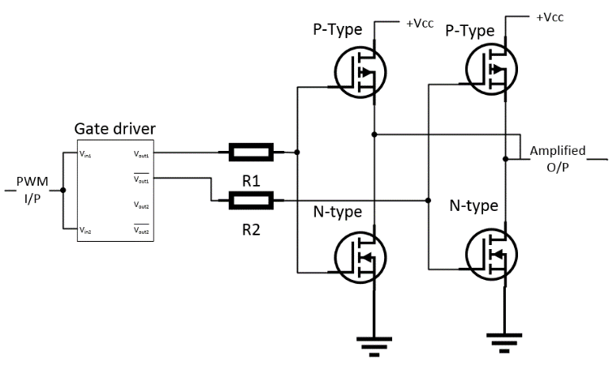

Figure : Full bridge rectifier circuit

## Signal processing

### Design requirements

Since the switching circuit produces high-frequency signals, a low pass filter is used to remove the higher frequencies (above 20 kHz) to recover the amplified version of the original audio input.

The following aspects of the circuit are considered:

* A flat frequency response is required to reduce any ripples in the amplitude of the signal.
* A short transition time for a more responsive system.

### Butterworth filter

Most audio systems are designed with a Butterworth low pass filter because of its flat frequency response of the passband. A filter with a flatter frequency response produces an output that has fewer enhancements such as amplitude and phase shifts while removing high frequencies. This produces a purer audio signal. Most class-D amplifiers use a first-order filter design with a cut-off frequency of just over 20 kHz to include frequencies the human ear can hear.

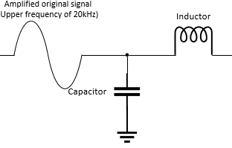

Figure : First order low pass Butterworth filter

## Bone conduction transducer

### Component description

The surface conduction transducer (more commonly known as the bone conduction transducer) is a speaker without a cone to propagate out the electrical input signal as sound. Instead, the transducer translates an electrical input into vibrations only and creates a speaker when pressed against a surface or cavity.

The transducer contains a metal rod with a voice coil wrapped around it. When a current is pulsed through the coil, the metal expands and contracts to create vibrations.

According to the technical description of the transducer, it has an input impedance of 8ohms and is recommended to run at around 1 W for small-scale audio systems.

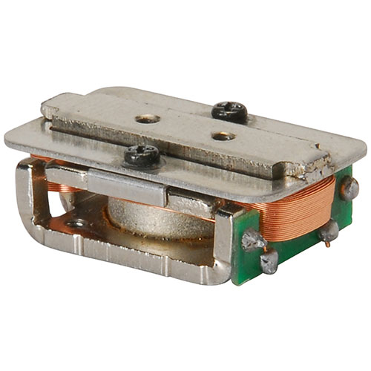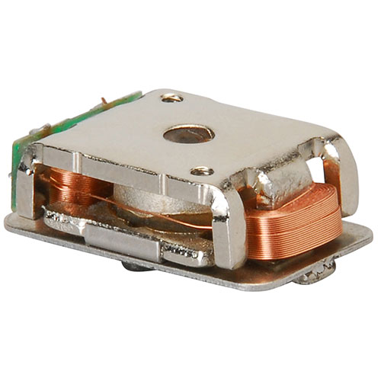

Figure : (Parts Express, 2018) [7]

### Applications

A transducer of this size is typically pressed up against the ear or jaw bone. The vibrations conduct along bone using the skull cavity as the speaker. However, this can also be applied to small speakers of the same input impedance.

### Possible dangers and side effects

The transducer and its connections be should be covered if applying the transducer directly against the human skin for long periods of time to avoid shorting the circuit due to sweat. [8]

## Initial design

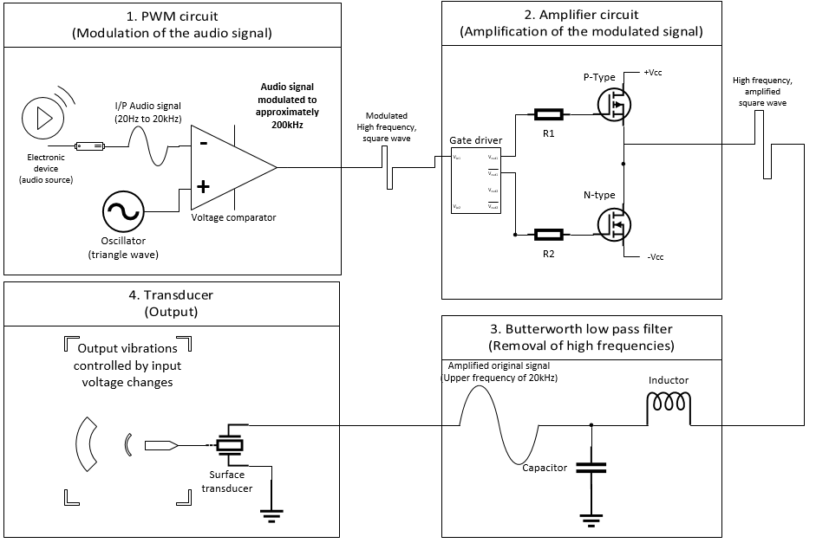

Figure : Initial design of project base on initial research

# Technical description and construction details

## Pulse width modulator

The pulse width modulation was chosen to modulate the audio signal as this technique dissipates less heat than pulse density modulation making the overall circuit more efficient.

The modulator works by comparing the voltage an incoming audio signal with a high-frequency triangle or sawtooth waveform. An LM741 IC is used to compare the signals while an LM555 timer generates a free running oscillating signal as the reference. Technical detail regarding these IC’s is included in the appendix section of this report.

### Component list

**Table 1: List of components used in pulse width modulation**

|  |  |  |  |
| --- | --- | --- | --- |
| **Component** | **Size** | **Quantity** | **Function** |
| Resistor | 2200Ω | 2 | To control the duty cycle of O/P |
| Capacitor | 333nF | 1 | To control slope of signal |
| Capacitor | 47µF | 1 | To determine the pulse width |
| LM555 IC | 8-pin PDIP | 1 | Switching between charge/discharge times |

### LM555 timer

The 555 timer operates in either the mono-stable mode or the a-stable mode depending on the application. In this case, the timer is configured in the astable mode to generate a free-running oscillating reference signal.

The schematic below is simply an illustration of the layout of the 555-timer in the a-stable mode and is a non-functioning schematic. The components inside the IC are oversimplified but are enough to explain the operation of timer. Details of the pin functions are included in the appendix section of this report.

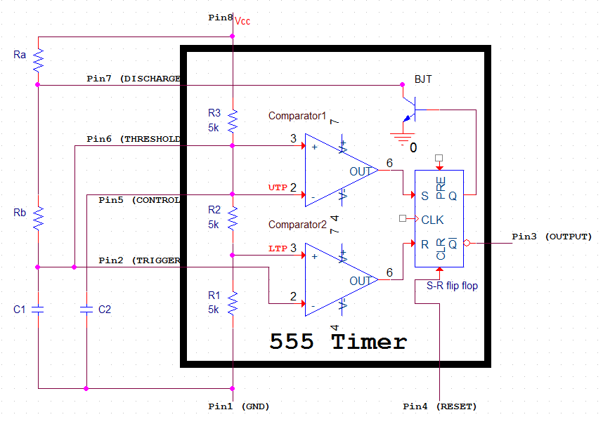

Figure : LM555 timer configured in the a-stable mode

The LM555 is connected to a 5 volts DC supply with a supply current between $3 mA to 6 mA$. The three 5 kΩ resistor present inside the circuit divide the voltage equally into three voltage. This sets the upper trip point (UTP) and lower trip point (LTP).

$$UTP=\left(\frac{5kΩ+5kΩ}{5kΩ+5kΩ+5kΩ}\right)*V_{cc}=\frac{2V_{cc}}{3} ; LTP=\left(\frac{5kΩ}{5kΩ+5kΩ+5kΩ}\right)*V_{cc}=\frac{V_{cc}}{3}$$

In the case with a supply voltage of 5 volts:

$$UTP=\frac{2(5v)}{3}=3.333v : LTP=\frac{5v}{3}=1.667v$$

When the 555 timer is in the a-stable mode two external resistors ($R_{A} and R_{B}$) and capacitor ($C_{1}$) are used to control the period and therefore the frequency of the output signal.

When the supply voltage ($V_{cc}$) applied the capacitor ($C_{1}$) begins to charge to the supply voltage $V_{cc}$ through both the resistors $R_{A}$ and $R_{B}$. The time taken for the capacitor to charge to the supply voltage depends on the size of the capacitor ($C_{1}$) and the size of both resistors. The equation for the charge time ($t_{1}$) is given by:

$$t_{1}=0.69\left(R_{A}+R_{B}\right)C_{1}$$

However, the voltage in the capacitor $C_{1}$ does not reach the supply voltage but instead begins to discharge when the UTP is reached. This is because the capacitor is connected to comparator 1 (pin 6). When the voltage in the capacitor reaches its UTP, the comparator sets the J-K flip-flop in the circuit.

In the set state, the flip-flop outputs a low signal to the output pin (pin 3) and a high voltage signal to the base of a BJT transistor. This connects the external capacitor ($C_{1}$) to ground through the discharge pin (pin 7) and through the transistor causing the capacitor to discharge its voltage though the resistor $R_{B}$ only. The capacitor attempts to discharge all of its voltage through the internal transistor. However, the second comparator in the circuit resets the flip-flop when the capacitor voltage has discharged to the LTP. In the reset state, the flip-flop outputs a high signal to the output pin (pin 3) and a low signal to the transistor no longer grounding the external capacitor. This causes the capacitor to start charging again.

The equation for the discharge time is given by:

$$t_{2}=0.69\left(R_{B}\right)C_{1}$$

By adding the rise and fall time of the voltage in the capacitor the period is calculated and therefore the frequency of oscillation:

$$Period=t_{1}+t_{2}=0.69\left(R_{a}+{2R}_{B}\right)C_{1} ; Oscilation frequncy=\frac{1.44}{\left(R_{a}+{2R}_{B}\right)C_{1}}$$

### Technical design

Figure 10 shows the initial design of the oscillator used in the modulator circuit. The circuit is supplied with 5 volts and 5 mA of current to pin 8 and pin 4. The circuit is probed at the capacitor C where the triangular waveform is produced and at pin 3 where a square wave of the same frequency is generated.

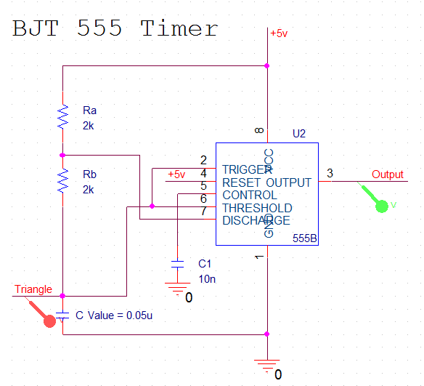

Figure : PSpice schematic of the LM555 in the a-stable mode

The external resistors in the circuit control the duty cycle of the waveform. By setting resistors $R_{a}$ and $R_{b}$ to equal each other the duty cycle is set to approximately 66.6%. The triangular waveform is used as the reference voltage for modulation.

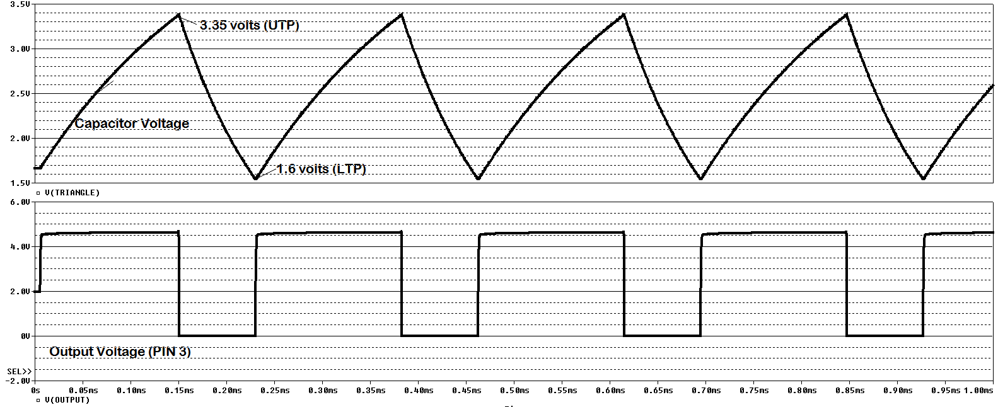

Figure : Voltage waveforms displayed for the output on pin 3 and the capacitor voltage

By decreasing the values of the resistors $R_{A}$ and $R_{B}$ and capacitor C the frequency of both the output square wave at pin 3 and the triangle waveform would increase at the same rate. However, in the a-stable mode the Pspice model of the 555 timer stops oscillating when reaching approximately 10 kHz.

The datasheet for the LM555 states that the timer can generate oscillation frequencies of up to 1MHz but does not specify whether this is true for the mono-stable or a-stable mode.

### LM741

The LM741 compares the voltage waveforms of the audio signal with the reference voltage generated by the oscillator.

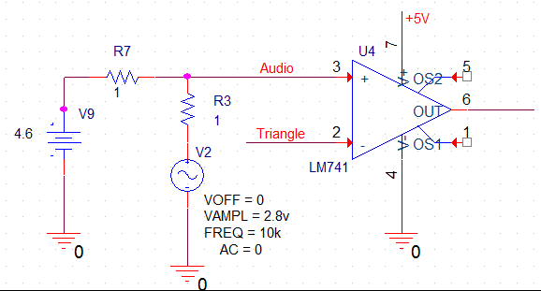

Figure : LM741 voltage divider with an audio signal and reference voltage compared

For simulation purposes, the amplitude and DC offset of both incoming signals are matched.

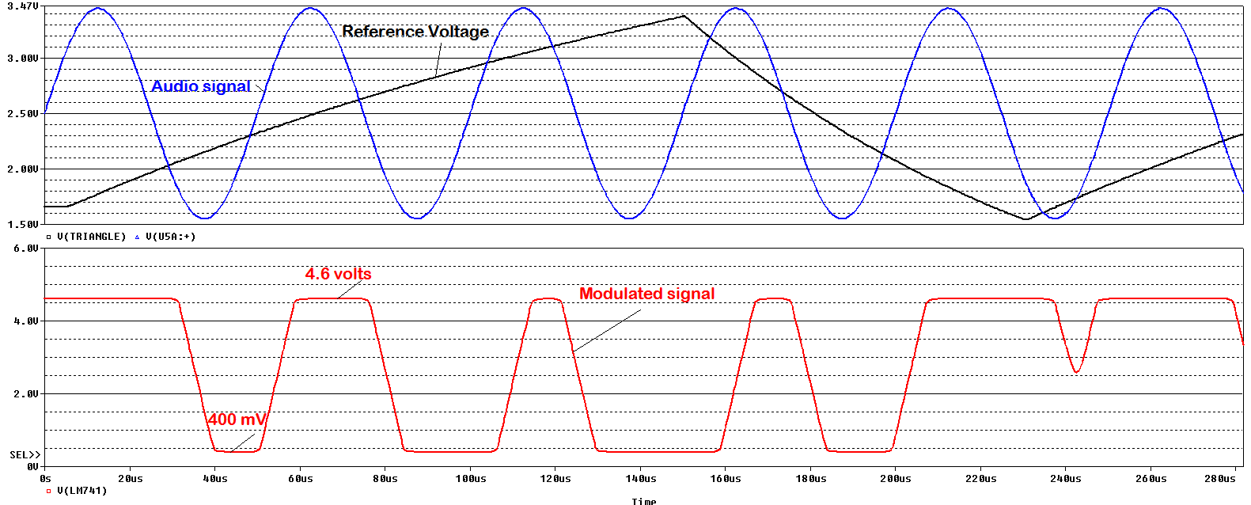

Figure : PSpice simulation of pulse width modulation

### Assembly

An initial prototype of the oscillator circuit was assembled on a breadboard to compare the results of the physical circuit and the Pspice simulation.

The LM555 is supplied with 5 volts DC signal with a supply current of 5mA.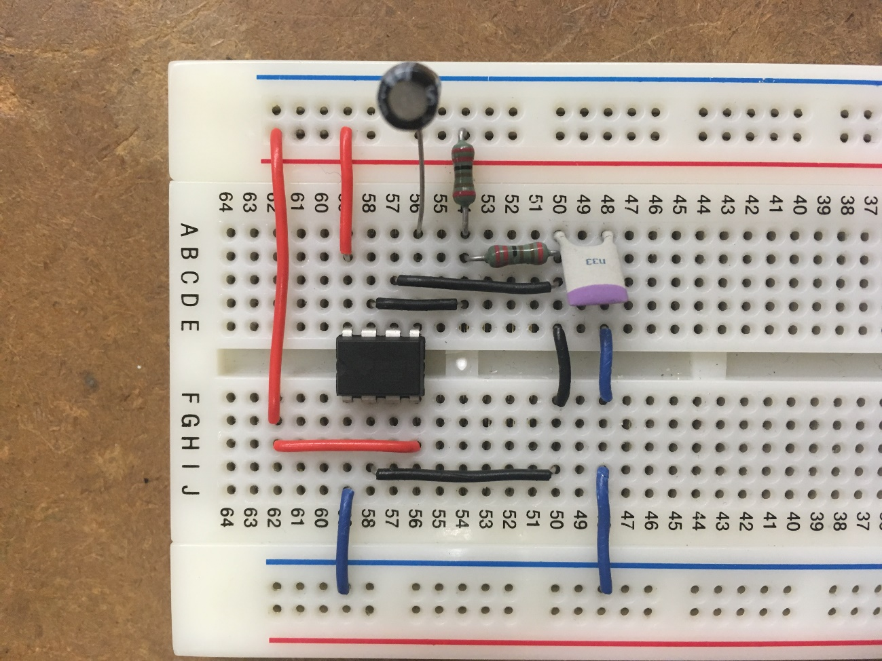

+Vcc

Figure : Oscillator assembled on a breadboard

GND

LM555

47µF Cap.

$$R_{A}$$

$$R_{B}$$

2200 kΩ Resisters

330nF Cap.

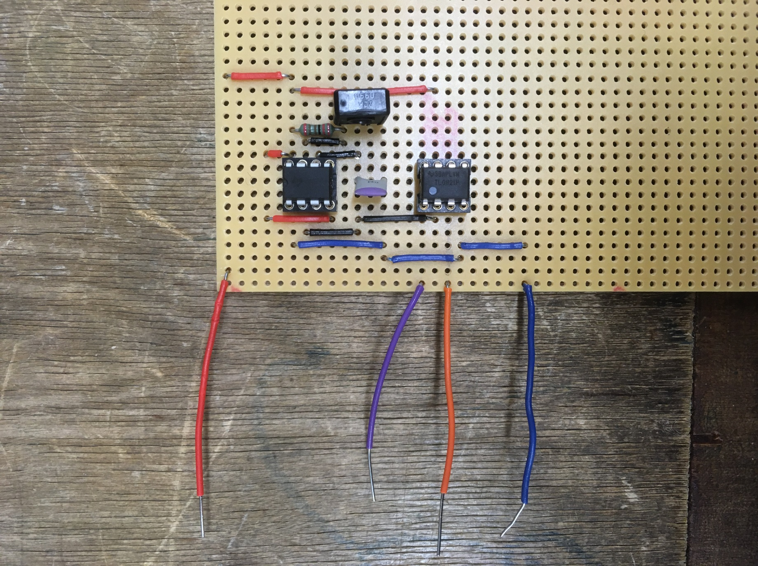

+Vcc

Modulated

Signal

Audio i/p

GND

TL082

LM555

10kΩ Variable resistor

Figure : Pulse width modulation circuit assembled and soldered on to stripboard

The complete assembly of the pulse width modulator is shown in figure 15. Resistor $R_{B}$ is replaced with a $10 kΩ$ variable resistor to allow for easy control of the duty cycle and therefore the frequency of the reference voltage.

The LM741 is replaced with the TL082 voltage comparator due to its faster slew rate. This becomes important when modulating high amplitudes at higher frequencies. Figure 16 shows the difference between both IC when applying to the same pulse modulation technique.

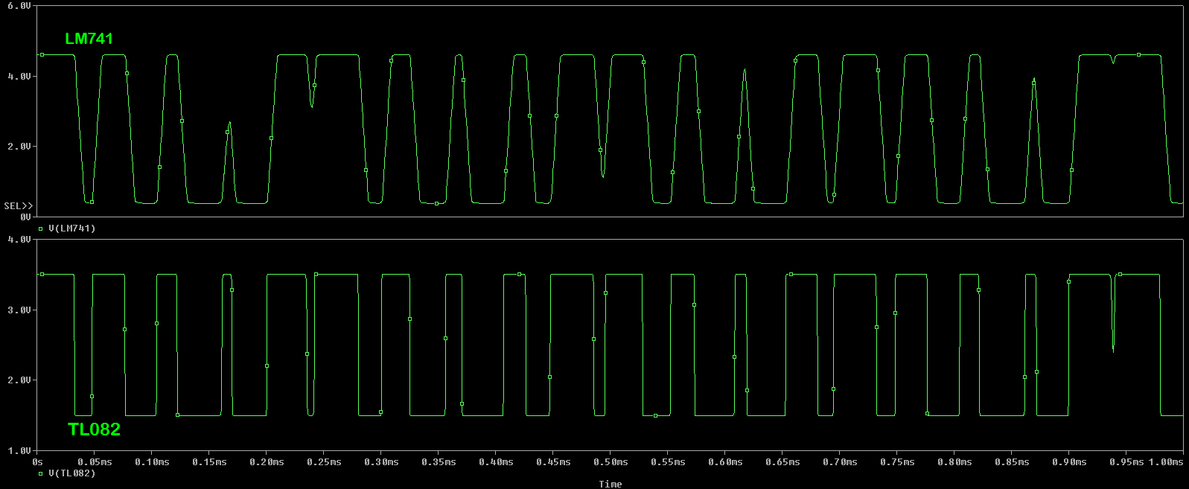

Figure : LM741 vs TL082 modulation

Slew rate of the LM741 is rated at 0.5v/µs while the TL082 is rated to have a slew rate of 13v/µs. This difference can be seen from the simulation results in figure 16.

## Class-D amplifier

### Component list

**Table 2: List of components used in switching circuit**

|  |  |  |  |
| --- | --- | --- | --- |
| **Component** | **Size** | **Quantity** | **Function** |
| Resistor | 100Ω | 2 | To reduce time taken to switch transistors on |
| Fast recovery diode |  | 2 | To reduce time taken to switch transistors off |
| MIC4125 driver | 8-pin | 1 | To switching time of transistors |
| IRLZ44N Power MOSFET |  | 2 | To control the flow of current through circuit |

### Technical design

The switching circuit (shown in figure 17) uses a MIC4125 gate driver to take in the pulse width modulated square wave signal from the modulator circuit as its input. The driver outputs a high current version of its input to quickly load the capacitive gate terminals of each complementary MOSFET transistors increasing the switching speed. The gate driver has two output pins which are always in opposite states to each other. This ensures that both transistors are not switched on at the same time as this would allow current to flow from both transistors causing the $+15 volts$ supply to appear across the circuit damaging components inside.

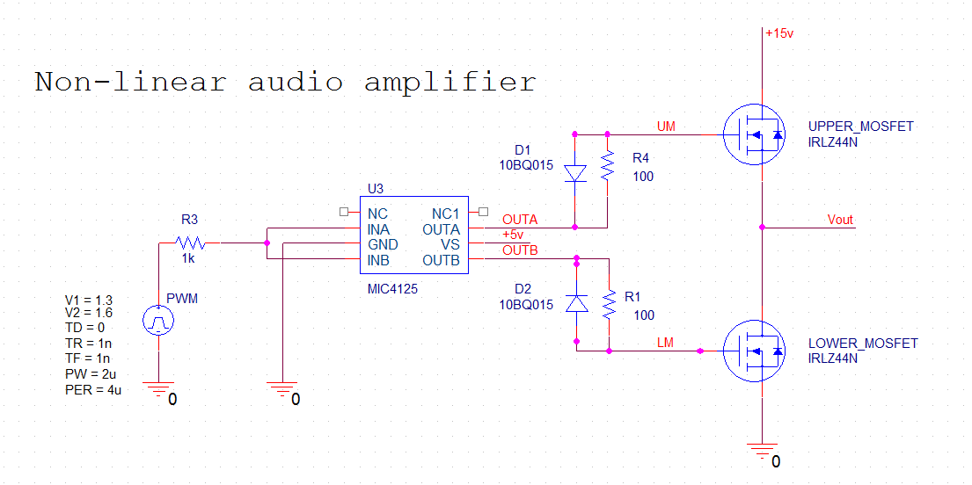

Figure : Switching circuit

Small resistors are placed in series with the gate of each MOSFET to reduce this time taken for the transistors to enter into saturation.

Fast recovery diodes are placed in parallel with the resistors to allow voltage to discharge as quickly as possible from the gate terminal.

This combination of resistor and diode ensures that the gate voltage on each transistor charges and discharges as quickly as possible. A delay is introduced between switching states in the circuit. The time where both transistors are switched off is referred to as “*dead time*”. While this removes the danger of damaging the circuit, increasing the dead time increases distortion in the signal reducing the quality of the audio signal.

Therefore, the circuit is designed to minimise this *dead time* while avoiding shorting the circuit.

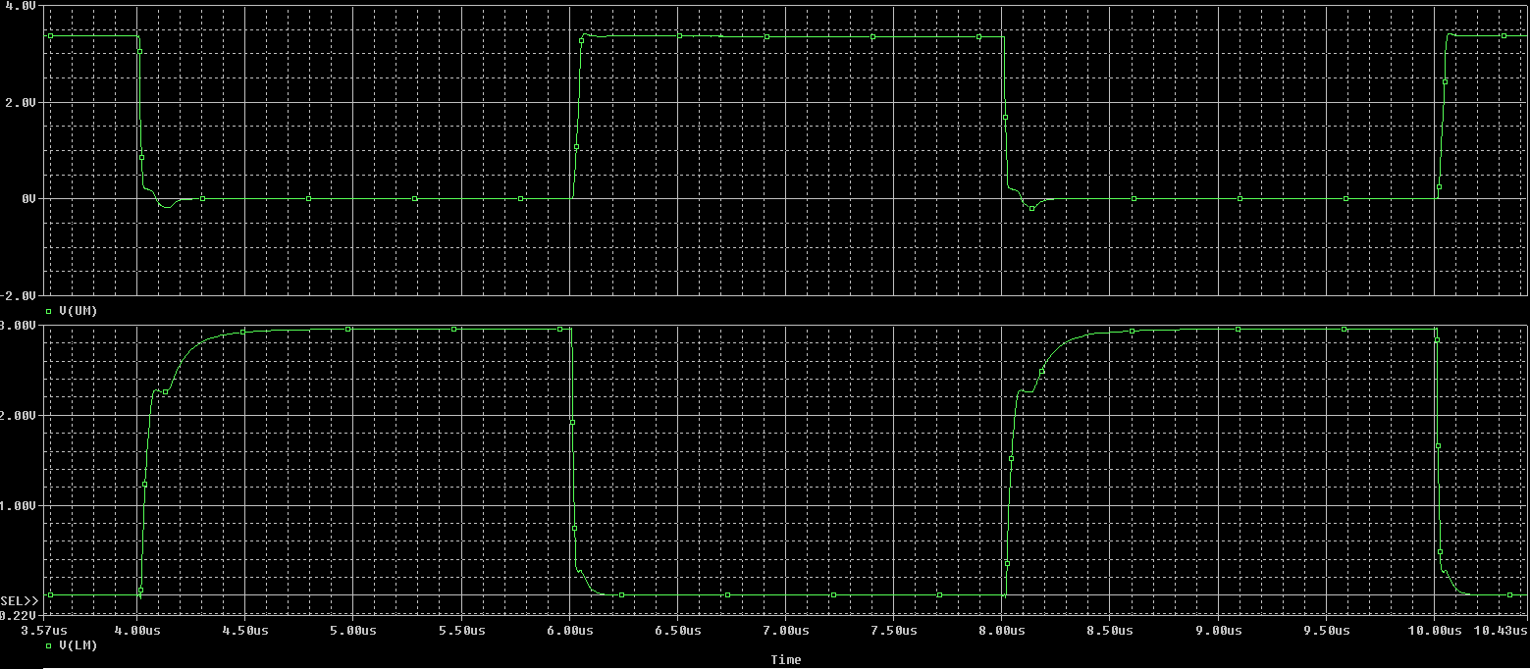

Figure : Two MOSFET gate terminals being loaded by the gate driver

Figure 18 shows the voltages being supplied to the gate terminals of the MOSFET transistors. Notice while one input is high the other is low. This design shows no dead time being implemented as the MIC4125 does not have this function built-in. However, the cross over in voltages occurs at smaller voltages reducing the risk of circuit failure.

# Test procedures and results

## LM555: Oscillation frequency testing

### Aim of test

This experiment aims to test the oscillating frequency of an LM555 timer in the A-stable and compare the test results with simulation results. As previously mentioned in this report, the timer would not oscillate at frequencies higher than 10 kHz.

### Equipment used

* TTI EL302RT triple 30 volt DC power supply
* Hewlett Packard 34401A Multi-meter
* Agilent 33120A 15 MHz function generator
* Hewlett Packard 54603B 60MHz oscilloscope
* Scope probes

### Method

The 555 timer is assembled on a breadboard in the A-stable mode. The timer is supplied with 5 volts DC and 5mA of current. The circuit includes two $2 kΩ$ external resistors. The size of the capacitor is reduced, increasing oscillation frequency of the output signal. Oscillating frequency of the circuit noted and graphed. Additionally, results for the duty cycle and peak to peak voltage of the signal is measured and noted along with the oscillating frequency.

### Results

The circuit behaved as expected to output the expected waveforms at lower frequencies. To see how the circuit would perform at higher frequencies the size of the capacitor (the 330 nF capacitor in figure 4) was decreased from an initial value of 47µF to 100 pF.

The table of results below displays the behaviour of the timer during the experiment. The table includes the expected oscillating frequency, the actual oscillating frequency measured and the difference between the two frequencies. The table also includes data on the change in the duty cycle and peak-peak voltage of the output signal concerning the change in the capacitance of the capacitor.

|  |  |  |  |  |  |  |  |
| --- | --- | --- | --- | --- | --- | --- | --- |
| **Column1** | **Column2** | **Column3** | **Column4** | **Column5** | **Column6** | **Column7** | **Column8** |
| $$R_{A}$$ | $$R_{B}$$ | C | Calculated value | Measured value | Error difference | Duty cycle | Voltage peak- peak |
| 2210Ω | 2210Ω | 47µF | 4.62 Hz | No reading | ? | ? | ? |
| 2210Ω | 2210Ω | 22µF | 9.87 Hz | No reading | ? | ? | ? |
| 2210Ω | 2210Ω | 10µF | 21.7 Hz | No reading | ? | ? | ? |
| 2210Ω | 2210Ω | 100nF | 2.17 kHz | 2.17 kHz | 0% | 55% | 31.25mV |
| 2210Ω | 2210Ω | 33nF | 6.582 kHz | 6.154 kHz | 6.50% | 55% | 1.7v |
| 2210Ω | 2210Ω | 22nF | 9.872 kHz | 9.542 kHz | 3.34% | 55% | 2v |
| 2210Ω | 2210Ω | 10nF | 21.719 kHz | 19.182 kHz | 11.68% | 55% | 2v |
| 2210Ω | 2210Ω | 1nF | 217.194 kHz | 158.8 kHz | 36.89% | 50% | 2.5v |
| 2210Ω | 2210Ω | 680pF | 319.403 kHz | 202 kHz | 36.76% | 48% | 2.593v |
| 2210Ω | 2210Ω | 430pF | 505.103 kHz | 252.2 kHz | 50.01% | 43-53% | 2.75v |
| 2210Ω | 2210Ω | 330pF | 658.165 kHz | 252.2 kHz | 61.68% | 53% | 3.359v |
| 2210Ω | 2210Ω | 150pF | 1.45 MHz | 254.8 kHz | 82.42% | 63-66% | 4.375v |
| 2210Ω | 2210Ω | 100pF | 2.17 MHz | 255.1 kHz | 88.13% | 72.40% | 4.469v |

**Table 3: Test result from the LM555**

* Inconclusive results. Oscilloscope could not read signal
* Measured results begin to deviate from the expected results
* Value of capacitor used in the prototype

$$Calculated value=Oscillating freq.=\frac{1.44}{0.69\left(R_{A}+2R_{B}\right)C}$$

### Observations

As seen in table 6 the circuit begins outputting lower frequencies than expected after 20 kHz (which is still 10 kHz than in the Pspice simulation). By further reducing, the value of the capacitor the circuit performed oscillating frequencies of up to 255 kHz. This data is graphed and is included in the Appendix section (figure 28 & 29, sub-section 8.8) of the report.

During the experiment, removing the capacitor from the circuit resulted in the timer to begin oscillating at approximately 250 kHz. However, the waveform then was no longer triangular but was a squared pulse with a slight undershoot at the rising edge with an increased. The waveforms can be found in the appendix section (figure 26 & 27, sub-section 8.7) of this report.

### Comments

The oscillating frequency of the timer seems capped at 250 kHz and oscillates at this frequency when removing the capacitor from the circuit. For the circuit to oscillate with no capacitor, there must be parasitic capacitance present within the 555 timer influencing the charge and discharge time in the voltage.

By adding a small enough capacitor, the duty cycle of the output is set to 50% generating a perfect triangle waveform. Ultimately, the oscillator performs best with a 330nF capacitor producing triangle waveform near to 50% and a frequency of 250 kHz that is required of the circuit.

## Modulation test 1

### Aim of test

This experiment aims to test the TL082 voltage comparator performance when applying to pulse width modulation.

### Equipment used

* TTI EL302RT triple 30 volts DC power supply
* Hewlett Packard 34401A Multi-meter
* Agilent 33120A 15 MHz function generator
* Hewlett Packard 54603B 60MHz oscilloscope
* Scope probes

### Method

Two voltage inputs are applied to the inverting and non-inverting input pins of the comparator with the same amplitude, same DC offset but at different frequencies. A high-frequency triangle wave is fed to the inverting pin from the LM555 oscillator as the reference voltage. An audio signal (sinewave) is fed to the non-inverting pin of the comparator. The audio signal is created using a function generator. The frequency of the sinewave signal is varied between 20 Hz and 20 kHz to represent a representation of an audio signal.

### Results

Figure 19 displays the overlapping waveforms to be compared to the TL082 voltage comparator.

Triangular waveform:

$$Frequency=205 kHz, V_{peak-peak}=2.56 v, V_{average}=2.2 v$$

Sinusoidal waveform:

$$Frequency=15 kHz, V_{peak-peak}=1.3 v, V_{average}=2.2 v$$

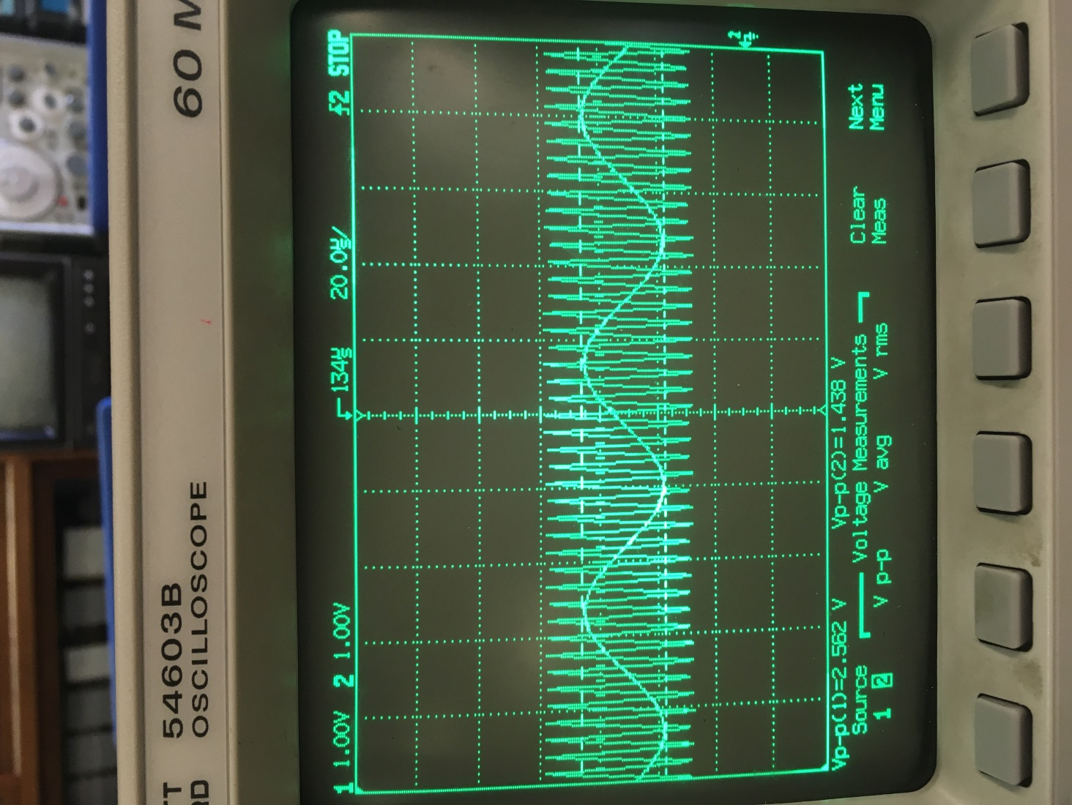

Figure : LM555 oscillating voltage signal compared with a function generated sinusoidal signal

The output of the TL082 (shown in figure 20) is seen to be a distorted version of the expected square wave output signal.

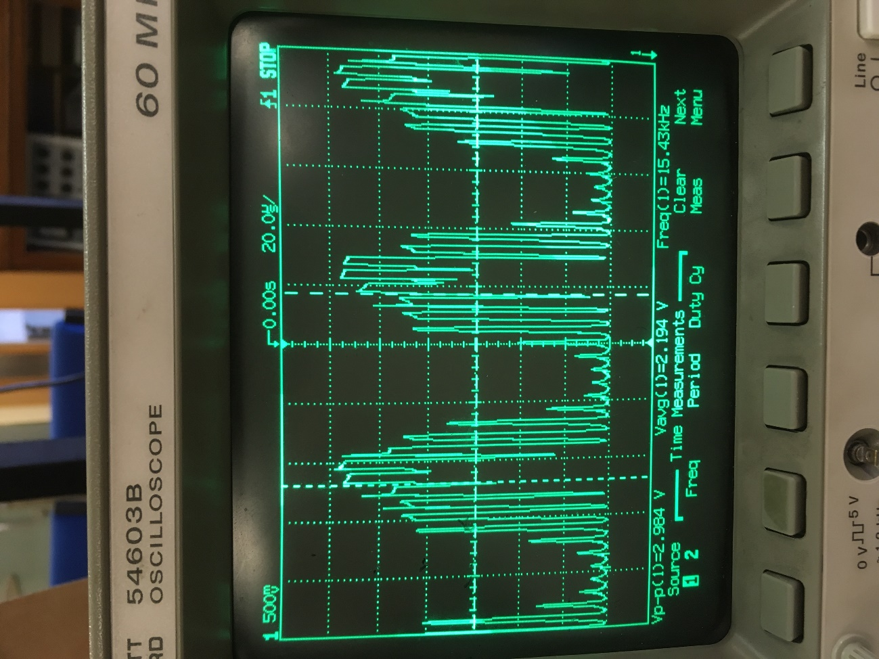

Figure : TL082 PWM output signal

### Observations

The distorted output of the TL082 voltage comparator seems to be caused by the slew rate of the comparator not being appropriate for such high-frequency operations. The expected output is a square wave signal, however, the output voltage does not seem to have enough time to change between low and high state.

Through inspection of figure 20 that, the amplitude of the square waves becomes smaller at its peaks. Beacause the reference voltage is triangular the rate at wich the comparator is being triggered at its input is incresing with the amplitude of the of the input audio signal.

## Modulation test 2

### Aim of test

The aim of this experiment is to test the performance of the TL084 voltage comparator as previously done the TL084. The TL084 has a higher slew rate of approximately $17 v/µs$ while the TL082 has a slew rate of $13 v/µs$.

### Method

The TL082 is replaced by the TL084 due to its superior slew rate.

### Results

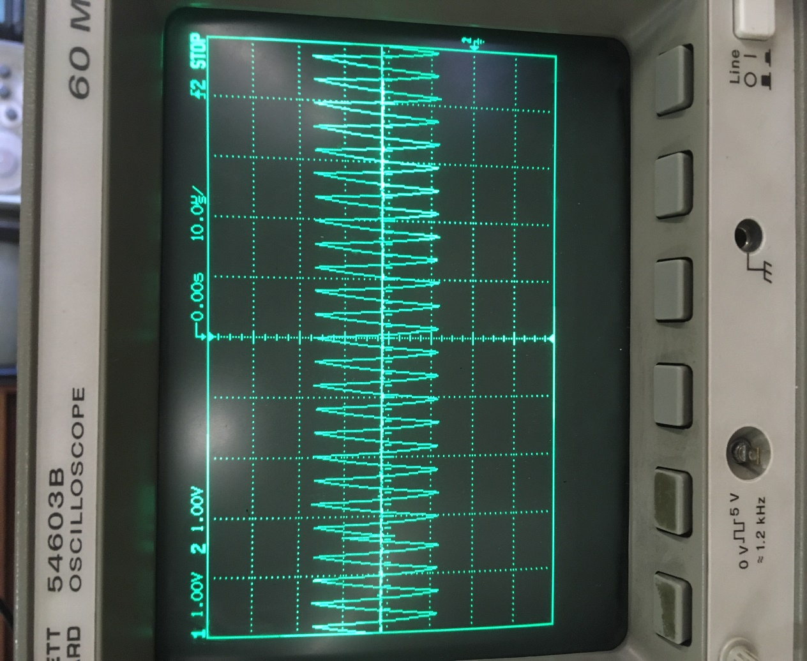A triangular waveform is supplied from the oscillator circuit to the inverting input of the TL084 comparator as the reference voltage. The triangular signals oscillate at 250 kHz. A sinusoidal waveform is supplied by the function generator as the audio signal to the non-inverting input of the comparator with a frequency of 1 Hz for test purposes.

Figure : TL084 comparator voltage inputs

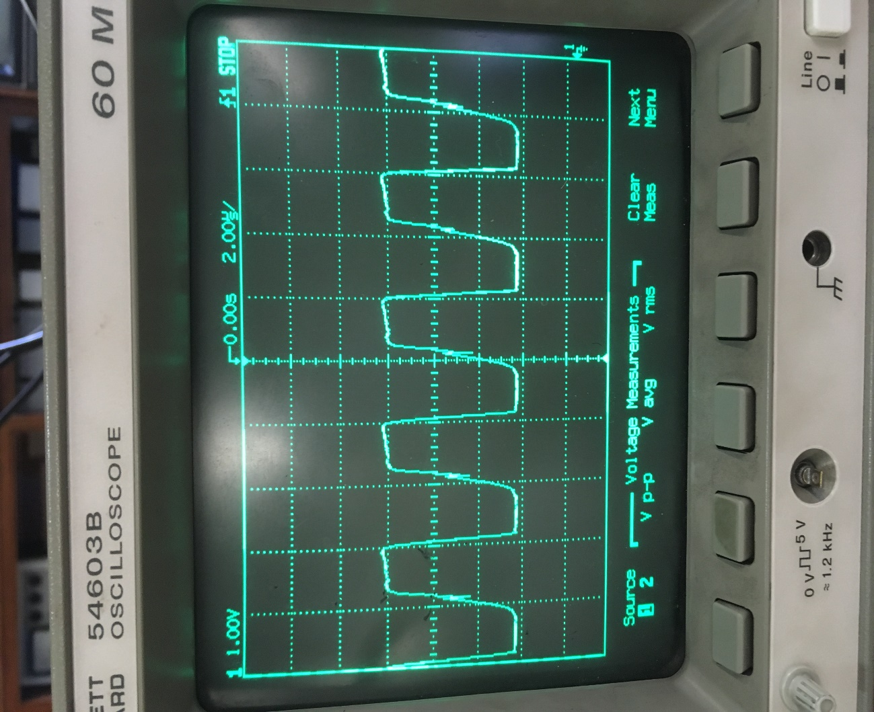

Figure : Output of the voltage TL084 comparator

The output oscillates at the reference voltage (250 kHz) as a square wave (seen in figure 22) between approximately 100 mV and 4.4 volts.

### Observations

The output of the TL084 comparator is much cleaner (as seen in figure 22) than the output of the TL082. The higher slew rate of the TL084 allows the output voltage to change quick enough to keep up with high-frequency triggering on the inputs of the comparator.

# Conclusion

The initial objective of this project was to design and build a Class-D amplifier circuit with a bone conduction transducer to amplify and output audio signals as vibrations to be later propagated out as an audible sound through a material such as a cone and act as a speaker.

Due to time constraints and several setbacks, only the first stage of the circuit (the modulator circuit) made it past the design stage and on to the assembly, and manufacturing stages.

Stage two and three (audio amplifier and low pass filtering) were designed and simulated based on initial research made in the early stages of the project.

The pulse width modulator (PWM) modulates an incoming sinusoidal audio signal with a frequency range between 20 Hz to 20 kHz into a high-frequency square wave signal.

# Recommendations

* The pulse width modulator needs to modulate the audio signal at least ten times the maximum frequency of the incoming audio signal to avoid total harmonic distortion caused by the switching frequency of the voltage comparator.
* The amplitude of the audio signal should be kept under 1.5 volts with a DC offset voltage of 2.2 volts for efficient modulation.
* A gate driver should be used in the design of the switching circuit to introduce a short amount of dead time between the switching MOSFETs to avoid shorting the amplifier.
* A Butterworth filter should be used to filter out high frequencies to minimise distortion of the original audio signal.

# References

[1] M. L. J. Chung, "A Comparison between GaN and Silicon Based Class D Audio Power Amplifiers with Pulse Density Modulation," University of Toronto (Canada), 2016.

[2] Class-D amplifier. (2018). [image] Available at: https://de.wikipedia.org/wiki/Klasse-D-Verst%C3%A4rker [Accessed 30 Mar. 2018].

[3] The output-signal pulse widths vary proportionally with the input-signal magnitude. (2007). [image] Available at: https://www.maximintegrated.com/en/app-notes/index.mvp/id/3977 [Accessed 23 Jan. 2018].

[4] S. Kovačević, T. Pešić-Brđanin, and J. Galić, "Intermodulation distortion of class D audio amplifier using pulse density modulation," in Zooming Innovation in Consumer Electronics International Conference (ZINC), 2016, 2016, pp. 46-49: IEEE

[5] Arduino (2018). Learning Arduino. [image] Available at: https://aprendiendoarduino.wordpress.com/ [Accessed 30 Mar. 2018].

[6] bone-conductive-transducer. (2014). [image] Available at: https://www.bc-robotics.com/wp-content/uploads/2014/02/bone-conductive-transucer-1.jpg [Accessed 23 Jan. 2018].

[7] Parts Express (2018). Bone conducting transducer. [image] Available at: https://www.parts-express.com/dayton-audio-bct-1-bone-conducting-transducer-exciter-22-x-14mm--240-610 [Accessed 30 Mar. 2018].

[8] P. Desrosiers, "Bone Conductor Transducer - BC Robotics", BC Robotics, 2018. [Online]. Available: https://www.bc-robotics.com/shop/bone-conductor-transducer/. [Accessed: 30- Mar- 2018].

[9] Texas Instruments (2015). Pin Configuration and Functions. [image] Available at: http://www.ti.com/lit/ds/symlink/lm555.pdf [Accessed 4 Apr. 2018].

[10] Texas Instruments (2015). Pin Configuration and Functions. [image] Available at: http://www.ti.com/lit/ds/symlink/lm555.pdf [Accessed 4 Apr. 2018].

[11] Texas Instruments (2015). Pin Configuration and Functions. [image] Available at: http://www.ti.com/lit/ds/symlink/lm555.pdf [Accessed 4 Apr. 2018].

[12] Texas Instruments (2001). TL084 pin connections. [image] Available at: https://www.egr.msu.edu/eceshop/Parts_Inventory/datasheets/tl084cn.pdf [Accessed 9 Apr. 2018].

# Appendices

## Block diagram

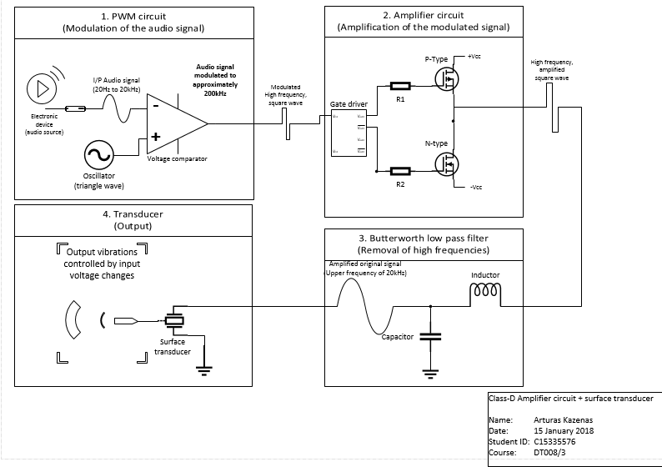

Figure : Initial design of the class-D amplifier circuit

## Schematic diagrams

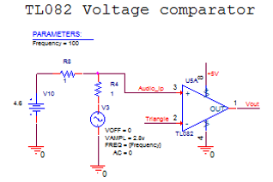

Figure : Spice schematic of the TL082 voltage comparator

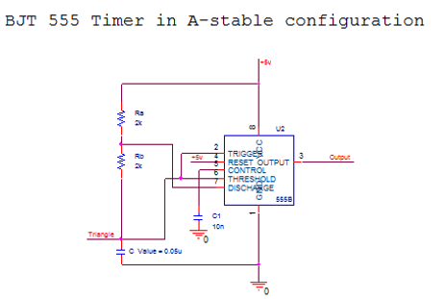

Figure : PSpice schematic diagram of the LM555 timer in the a-stable mode

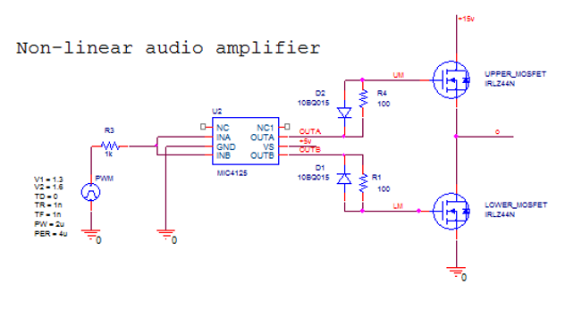

Figure : PSpice schematic of the non-linear amplifier circuit with a square wave input

## LM555 pin layout

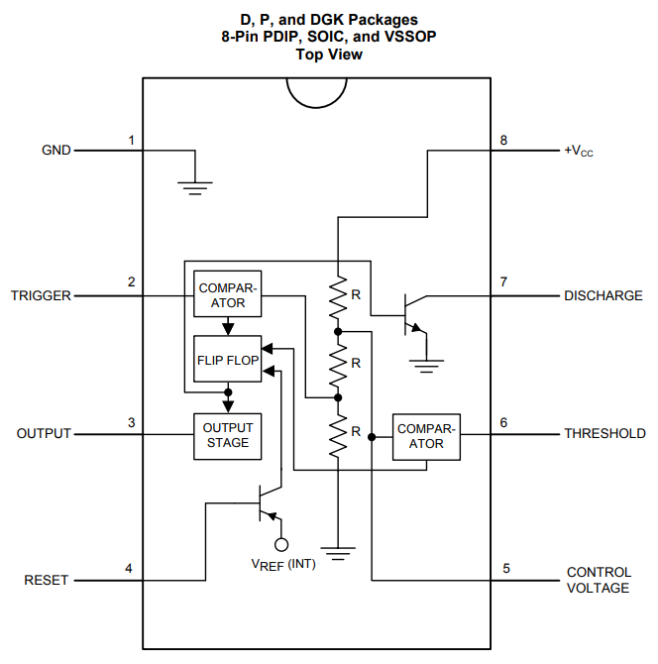

Figure : (Texas Instruments, 2015) [9]

## TL082 pin layout

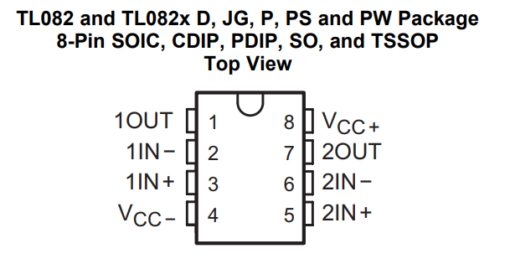

Figure : (Texas Instruments, 2015) [10]

## LM741 pin layout

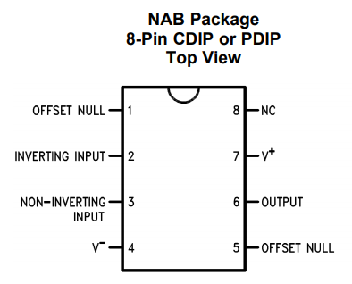

Figure : (Texas Instruments, 2015) [11]

## TL084 pin layout

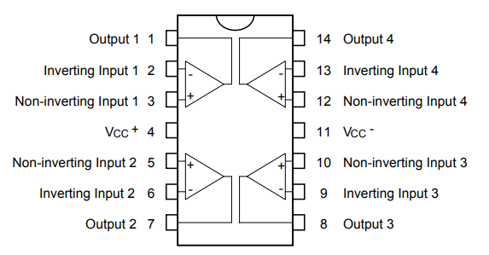

Figure : (Texas Instruments, 2001) [12]

## Components list

|  |  |
| --- | --- |
| Components | Quantity |
| LM555 Timer | 1 |
| TL082 operational amplifier | 1 |
| MIC4125 MOSFET Power Driver | 1 |
| IRLZ44NPbf N-channel power MOSFET | 2 |
| Electrolytic Capacitor 47µF | 1 |
| Ceramic Capacitor 330nF | 1 |
| 1N4148TR Switching Diode | 2 |
| Axial Fixed Resistor 2kΩ ±5% | 1 |
| Variable resistor 10 kΩ | 1 |

## Photos of results

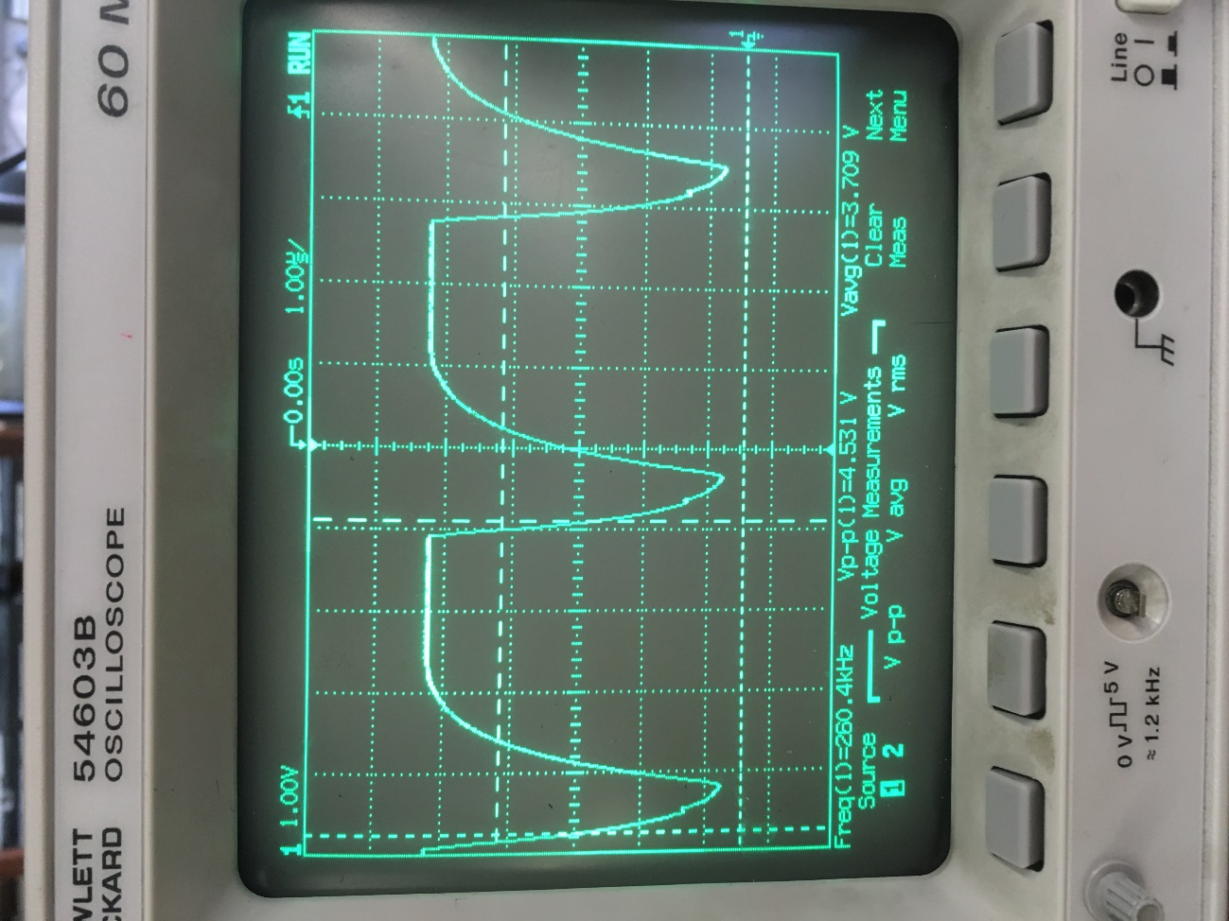

Figure : LM555 oscillating waveform with no external capacitor

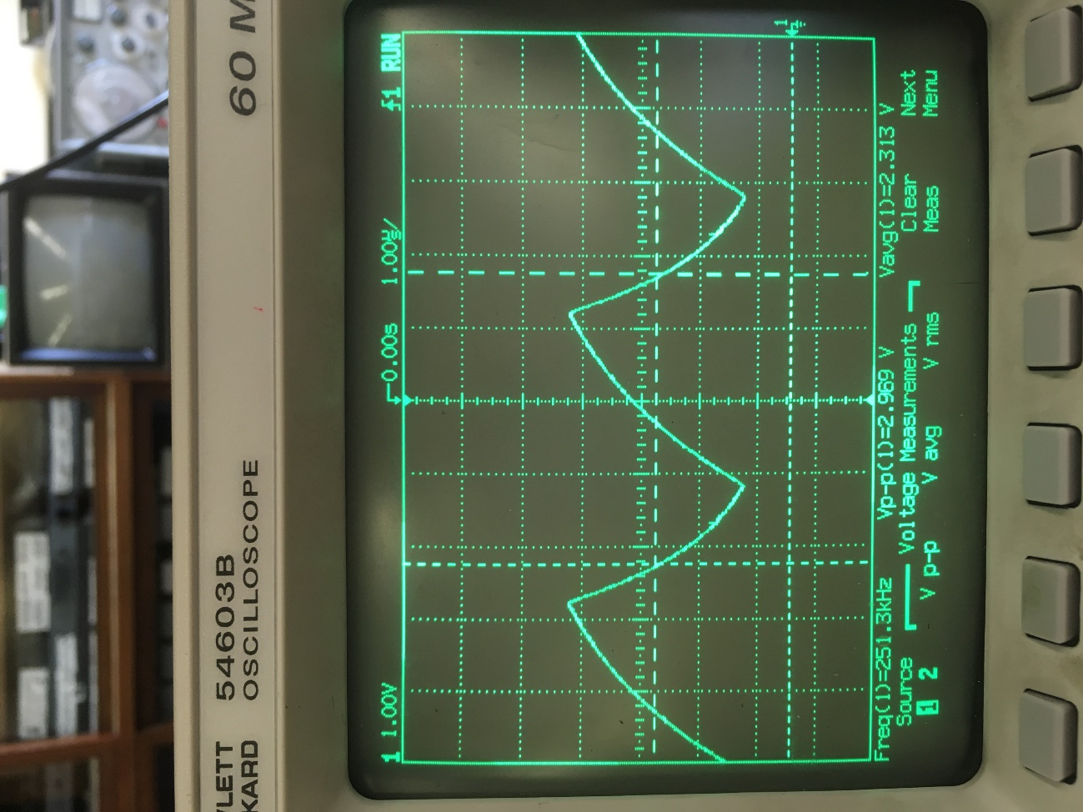

Figure : LM555 oscillating waveforms with an external capacitor

## Graphed results

Figure : Capacitor values used during frequency testing of the LM555

Figure : Oscillating frequency difference between expected and measured values during testing

## Photos of stripboard circuit

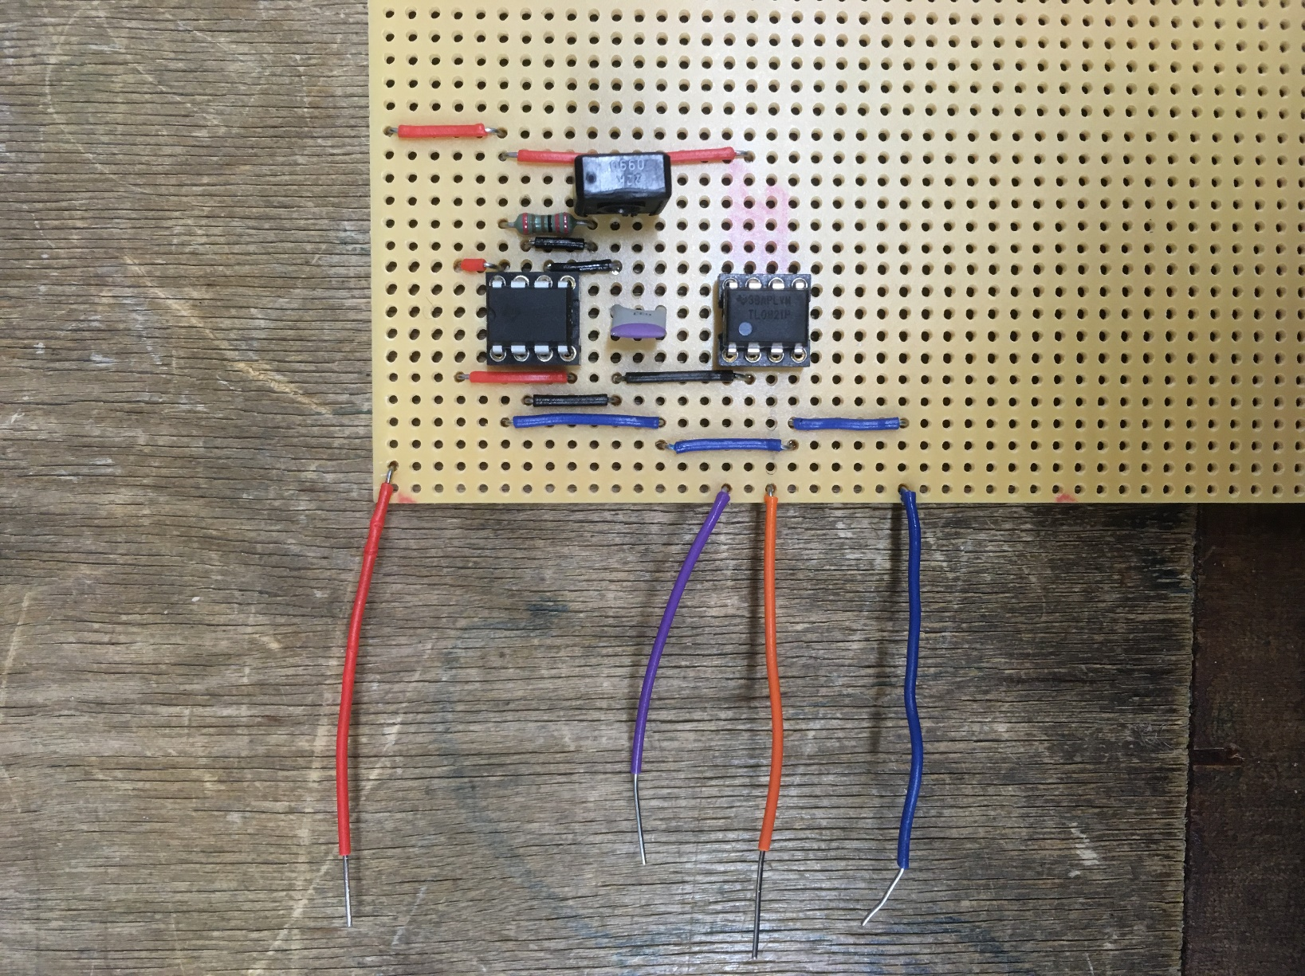

Figure : Photo of the pulse width modulator circuit (Top view)

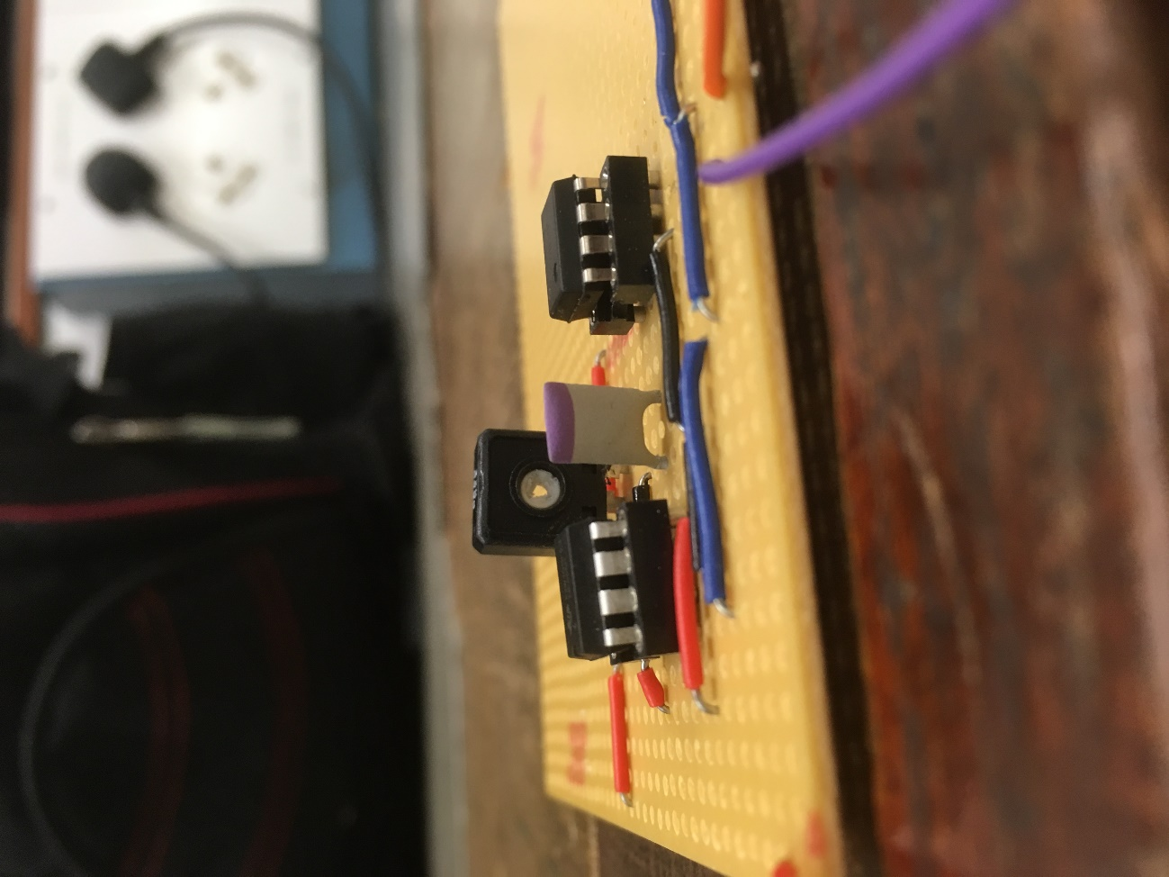

Figure : Photo of the pulse width modulator circuit (left-side view)

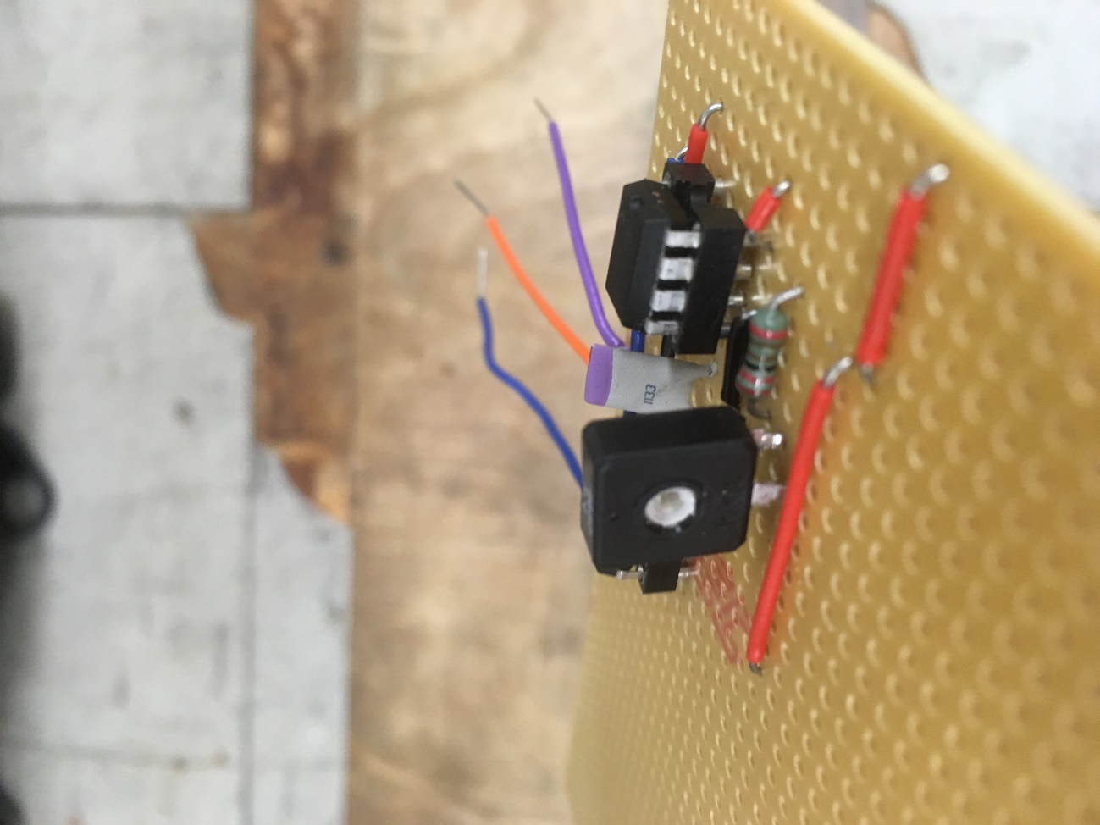

Figure : Photo of the pulse width modulator circuit (right-side view)

## Project schedule

The weeks referred to in this schedule are in line with the academic calendar of 2017/2018.

**Table 6: Semester 1 schedule**

|  |  |
| --- | --- |
| **Semester 1 (2017)** | |
| **Week** | **Task** |
| Week 9 | * Meet supervisor. * Setup a shared google drive file with my supervisor. |
| Week 10 | * Consideration of project tasks. * Draft a Gantt chart. |
| Week 11 | * Finalise the Gantt chart. * Draft a bill of components. * Collect datasheets. * Draft a block diagram of the project. * Begin the preliminary report. * Research pulse width modulation and gate drivers. |
| Week 12 | * Research amplifier circuits, signal processing filters and bone conduction transducers. * Finalise bill of materials. * Finalise the block diagram of the project. |
| Week 13 | * Research engineering ethics. * Bill of Materials Order & Lead-Time. |
| Week of Dec. 18th. (Christmas Holiday) | * Begin designing the pulse width modulation circuit. |
| Week of Jan. 8th  (Academic Holiday) | * Design gate driver circuit. * Design switching circuit. |
| Week of Jan. 15th  (Academic holiday) | * Design Low pass filter. |

Due to complication in the design process of the pulse width modulator circuit from 18-Dec-2017 to the 15-Jan-2018 the project has been cut back to the full design, assembly of the PWM circuit and the design of the switching circuit only.

**Table 7: Semester 2 schedule**

|  |  |
| --- | --- |
| **Semester 2** | |
| **Week** | **Task** |
| Week 1 | * Finalise Preliminary report. * Submit a preliminary report on the **24th of January.** |
| Week 2 | * Finish design of oscillator circuit. |
| Week 3 | * Start prototype assembly of the oscillator circuit. * Begin progress report. |
| Week 4 | * Finish assembly of the prototype. * Test circuit operation. |
| Week 5 | * Submit the progress report on the **21st of February.** |
| Week 6 | * Continue assembly of the PWM circuit. |
| Week 7 | * Finish assembly of the PWM circuit. |
| Week 8 | * Continue design of switching circuit. |
| Week 9 | * Finish design of switching circuit. * Begin final report. |
| Week of Mar. 26th. (Easter Holiday) | * Start preparing for the presentation. |
| Week of Apr. 2nd. (Easter Holiday) | * Finalise the final report. |
| Week 10 | * Submit the final report on the **10th April.** * Final review of presentation. * Deliver the presentation and interview on the **12th April.** |